HOW TO SPEED LIMIT DEFEAT YOUR CAR USING THE PROCEDE V.2
Disclaimer : warning this is only for Dyno test purposes. I will not be held responsible on the part of anyone performing this modification
Note : Make sure if you decide to intercept the speed signal wire of the factory ECU
as guided below, that you use the Speed Delimit map always and not the Speed limit
map, as this will cause your car to go into limp mode or produce CEL’s.
If you are not intercepting the road speed signal wire, either map can be used. It
doesn't matter.

Warning: Removing the factory speed limiter can be dangerous and irresponsible.

Basically you need to redirect the Speed Signal Wire from the BMW factory ECU and intercept and pass it thru the ProCede then modify the signal and return it to the BMW factory ECU. We will do this by using the spare Green Loom you removed when you upgraded from V1 to V2 ProCede to do this mod.

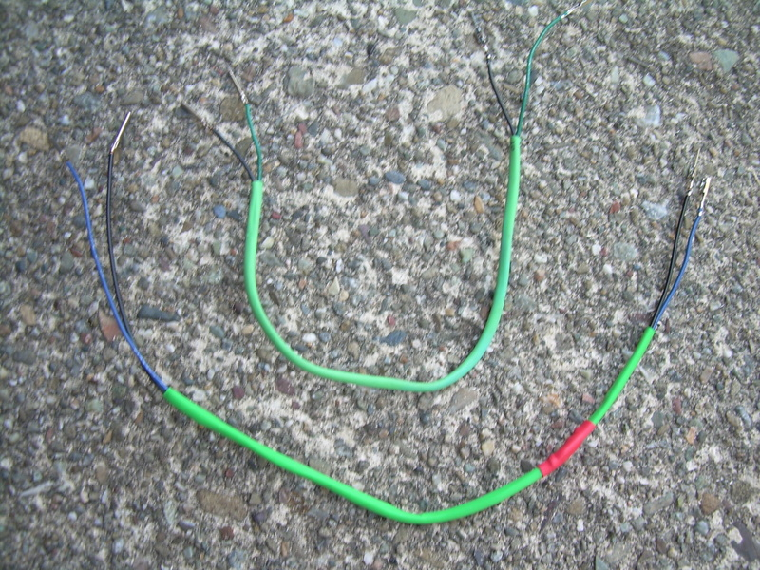

To Start :
Part a.) BMW ECU WIRE EXTRACTION

  - The BMW ECU has two connected looms. One of the two is smaller. Unplug the small loom connector from the ECU. Then look inside this loom connector and you will notice that there are a further two loom sub-connectors within – (Grey & Black). Locate the Grey sub-connector loom and unplug and slide it out.

  - Locate Pin no. 17 and extract the White/Green wire. This is the BMW factory ECU “Speed Signal Wire” we will use later on, to intercept it via the Digital I/O no. 4 of the ProCede ECU.

Part b.) GREEN LOOM TERMINATION

  - Now, you need to use the spare Green Loom left over from the ProCede V2 install-(shown in diagram above).
Inside this Green loom there are two wires. Black & Green.
Connect one end of the Black wire onto the extracted White/Green Speed
Signal Wire.( tape up making sure to conceal exposed pins).

Then connect the other end of the same Black wire into Pin no. 4 of the
ProCede Black Connector.

  - Next, inside the Green loom, locate the Green wire and connect one end into Pin no.17 in the Grey sub-connector loom of the BMW factory ECU. Lastly, connect the other end of the same Green wire to Pin no.9 of the ProCede Black Connector.

THIS CONCLUDES THE SPEED LIMIT DEFEAT MODIFICATION.

