Inserting extra wire loops for V.2 ProCede Upgrade
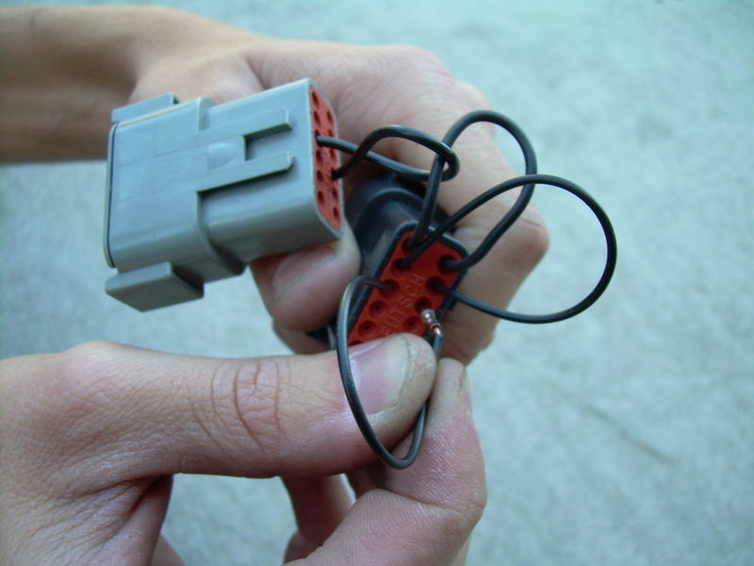

When done, it should look like this - three loops, (1-12) (2-11) (3-10) and if you are running
the Speed Limit Defeat a fourth loop needs to be installed – (4 - 9)

