BG Liquitech Fuel System & Throttle Body Service Kit

Fuel system maintenance is essential on modern vehicles. A complex network of electronic sensors control combustion, performance and exhaust emissions. Contamination from modern fuel interferes with the accuracy and efficiency of combustion, leading to poor fuel atomisation, excessive fuel use, high pollutant emissions and loss of performance. Heavy deposit accumulation in the throttle body assembly and plenum is common in modern fuel injected engines. This accumulation will reduce air flow and disrupt the critical air/fuel ration essential to efficient engine operation. Rough idle, poor performance, poor fuel economy and increased exhaust emissions are all common.
Today’s service customers expect noticeable improvements to their vehicle as a result of a routine service visit. Above all, driveability is one of the key improvement that influences whether the customer perceive money well spent on servicing was well spent and your service department or workshop worth a repeat visit.
BG Liquitech PETROL INJECTION FUEL SYSTEM CLEANER - Removes carbon and varnish deposits from injectors, values, combustion chamber, sensors and EGR systems. For use with BG Vehicle Injection Apparatus (VIA). DO NOT ADD FUEL TO THE TANK.
BG Liquitech CF5 - Our most advanced formula fuel tank treatment, CF5 ensures an even more effective clean up through deposit control technology and fuel stabilisers. Protects against rust and corrosion of the fuel system and its components. Add one 325ml bottle to the fuel tank while servicing vehicle with 210L and 206L products as referred here.
BL Liquitech AIR INTAKE SYSTEM CLEANER - A cleaning and degreasing formula that quickly and safely removes sticky, heavy deposits in the throttle body assembly and plenum of fuel injected engines. Specifically designed for modern electronically controlled systems. For use with BG AIS Cleaning tool (#9206).
- Restores combustion efficiency
- Improves driveability
- Reduces exhaust emissions
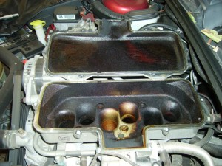  Manifold before clean | 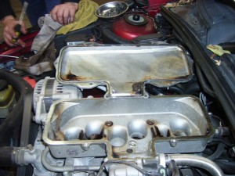  Manifold after clean

Designed for use on all petrol engines, including direct injection, high pressure, common rail and lean burn types.
