00 ... ... | Raising vehicle with trolley jack

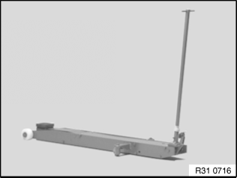 |  |  | Important!  Observe the following trolley-jack-related instructions:
  1. | Use only BMW-distributed/approved trolley jacks which have rubber plate contact points.
  2. | Trolley jacks must be regularly serviced and always checked for functional reliability before they are used!
  3. | Check the rubber plate on the trolley jack prior to each use, replacing if necessary.
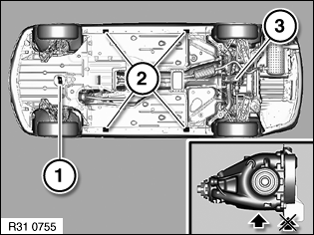 | Warning!  The vehicle may be raised with a trolley jack only at the following jacking points!
  1 | Car jacking point on reinforcement strut (rear-wheel drive)
  2 | Side car jacking points
  3 | Rear differential  Risk of damage: It is not permitted to raise the vehicle at the rear differential cover!

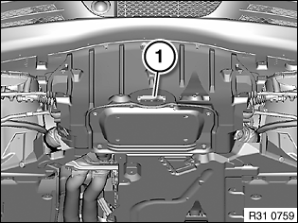
  1 | Car jacking point on front axle carrier (all-wheel drive)

